|  |  |
| --- | --- |
| **Assignment Case** |  |
| COMP6178  Introduction to Programming |
| **Computer Science** | **O213-COMP6178-MW01-02** |
| ***Valid on*** *Odd Semester Year 2020/2021* | **Revision 00** |

1. Seluruh mahasiswa tidak diperkenankan untuk:

*All students are not allowed to:*

* + 1. Melihat sebagian atau seluruh jawaban mahasiswa lain,

*Seeing a part or the whole answer from other student*

* + 1. Menyadur sebagian maupun seluruh jawaban dari buku,

*Adapted a part or the whole answer from the book*

* + 1. Mendownload sebagian maupun seluruh jawaban dari internet,

*Downloading a part or the whole answer from the internet,*

* + 1. Mengerjakan soal yang tidak sesuai dengan tema yang ada di soal,

*Working with another theme which is not in accordance with the existing theme in the matter of the case,*

* + 1. Melakukan tindakan kecurangan lainnya,

*Committing other dishonest actions,*

* + 1. Secara sengaja maupun tidak sengaja melakukan segala tindakan kelalaian yang menyebabkan hasil karyanya berhasil dicontek oleh orang lain / kelompok lain.

*Accidentally or intentionally conduct any failure action that cause the results of the project was copied by someone else / other groups.*

1. Jika mahasiswa terbukti melakukan tindakan seperti yang dijelaskan butir 1 di atas, maka **nilai mahasiswa** yang melakukan kecurangan (menyontek maupun dicontek) akan di – **NOL** – kan.

*If the student is proved to the actions described in point 1 above, the score of the student which committed dishonest acts (cheating or being cheated) will be “Zero”*

1. Perhatikan jadwal pengumpulan jawaban, segala jenis pengumpulan jawaban di luar jadwal tidak dilayani.

*Pay attention to the submission schedule, all kinds of submission outside the schedule will not be accepted*

1. Persentase penilaiaan untuk matakuliah ini adalah sebagai berikut:

*Marking percentage for this subject is described as follows:*

|  |  |  |
| --- | --- | --- |
| **Tugas Mandiri**  *Assignment* | **Proyek**  *Project* | **UAP**  *Final Exam* |
| 40% | - | 60% |

1. Software yang digunakan pada matakuliah ini adalah sebagai berikut:

*Software will be used in this subject are described as follows:*

|  |
| --- |
| **Software**  *Software* |
| Java 8  Eclipse 2020.6 |

## Ekstensi file yang harus disertakan dalam pengumpulan tugas mandiri dan UAP untuk matakuliah ini adalah sebagai berikut:

*File extensions should be included in assignment and final exam collection for this subject are described as follows:*

|  |  |  |
| --- | --- | --- |
| **Tugas Mandiri**  *Assignment* | **Proyek**  *Project* | **UAP**  *Final Exam* |
| JAVA, CLASS | - | JAVA, CLASS |

## Soal

*Case*

**ItemMuW**

**ItemMuW** is a website that can help gamer to sell their products. Because there’re so many scammers out there, we want to ensure that gamer can sell their products safely. You, as a programmer were tasked to create the program. The requirements are:

* The application consists of **3 menus**:

1. **Insert Product**
2. **Buy Product**
3. **Exit**

* If user choses **menu 1** (“**Insert Product**”), then the program will:
* Ask the user to **input** their **product name**. Validate product name **must be between 6 characters and 20 characters**.
* Ask the user to **input** their **product type**. Validate product type **must be** either “**Currency**”, “**Item**”, or “**Account**” **(Case Sensitive)**.
* Ask the user to **input** their **product price**. Validate price **must be between 10.000 and 1.000.000**.
* Ask the user to **input** their **product quantity**. Validate quantity **must be between 1 and 50.**

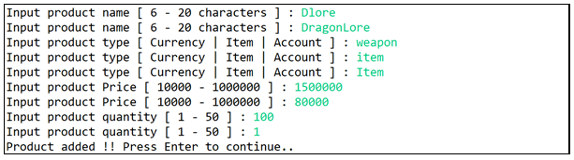

* Save the **product data** in a **Collection** (**Vector / ArrayList / Array**)**.**
* If user choses **menu 2** (“**Buy Product**”), then the program will:
* If there’s **no product**, then **display message** “**There’s no product..**”.

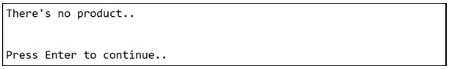

* Otherwise, display **all product data** that consist of **product name**, **product type**, **product price**, product **quantity,** and **subtotal**. Then, Ask the user if they want to **buy all product.** Validate that the **buy all** must be either “**Y**” or “**N**” (Case Sensitive).

* Calculate the **Sub Total** based on this formula:



* If user choose to **“Y”**, **display receipt** that consist of **total price, discount, tax,** and **grand total.**

* Calculate the **Total** base on this formula:



* Calculate the **Discount** base on this formula:



* Calculate the **Tax** base on this formula:



* Calculate the **Grand Total** base on this formula:



* After the receipt has been shown. **Remove all the items** from the **purchase list** and **return tto main menu**.
* If user choses **menu 3** (“**Exit**”), then the program will be closed.

**Good Luck**